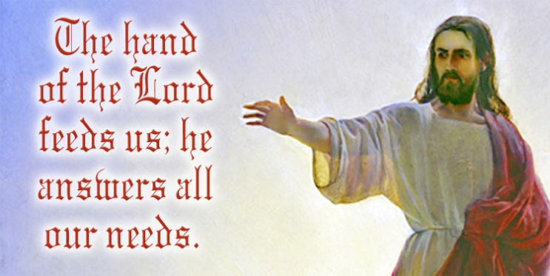

Dear Parish Family,

As I mentioned in my homily last week, as good as it is to go away on vacation, it is always good to come home. With more parishioners returning to Mass every weekend, I looked forward to seeing parishioners who may have returned while I was away.

All of us recognize the importance of family meals and family gatherings. At these gatherings, we appreciate everyone’s presence, but we also feel the absence of those who are missing. As a family, Little Flower parish appreciates your presence whenever you are here.

Thanks to the priests who filled in for me the two weekends I was away: Frs. Jim Bonke, Rick Ginther, and Larry Richardt. Incidentally, if you may have missed it, Archbishop Thompson recently named Fr. Rick Ginther, who is pastor of Our Lady of Lourdes, dean of the East Deanery.

Also, thanks to the staff for all they do for me and for the parish. We are blessed with a very dedicated and hard-working staff.

Finally, thanks to all of you for all you do to support the parish with your gifts of time, talent, and treasure. You are the parish! On a personal note, thank you for all the cards, notes, greetings, and gifts on the occasion of my 46th anniversary of ordination.

Thursday is the Feast of St. Mary Magdalene. Mary Magdalene is sometimes called the “apostle to the apostles” because she was the first to witness to the risen Christ.

Have a wonderful week.



**V3C.tif**

**For the Week of July 26 – August 1 , 2021**

|  |  |  |
| --- | --- | --- |
| **26** | **July** | **Monday** |
|  | 5:30 p.m. | For the Intentions of John T. Kelly |
| **27** | **July** | **Tuesday** |
|  | 5:30 p.m. | For the Intentions of Charlie Goodman |
| **28** | **July** | **Wednesday** |
|  | 5:30 p.m. | For the Intentions of Joy Valentine by Angel Adorey |
| **29** | **July** | **Thursday** |
|  | 5:30 p.m. | Bill Ross by the Commiskey Family |
| **30** | **July** | **Friday** |
|  | 5:30 p.m. | John Pen by Dick and Judy Sitzman |
| **31** | **July** | **Saturday –Vigil of The 17th Sunday in Ordinary Time** |
|  | 5:00 p.m. | David O’Conner by Friends |
| **01** | **August** | **Sunday – The 17th Sunday in Ordinary Time** |
|  | 9:30 a.m. | For the People |
|  | 6:00 p.m. | James Wagner by Family Friends |

V12C.tif

**July 25 – August 1, 2021**

|  |  |  |  |
| --- | --- | --- | --- |
| **DAY** | **ROOM** | **TIME** | **GROUP** |
| **Sunday** | Church | All Masses | Back to School Blessing |
| **Monday** | St. Therese | 6:30 p.m. | SoulCore |
| **Thursday** | St. Therese | 8:00 p.m. | AA |
| **Sunday** | 18th Sunday in Ordinary Time | | |

**Readings for July 31 & August 1**

**18th Sunday in Ordinary Time**

Exodus 16:2-4, 12-15

Ephesians 4: 17, 20-24

John 6:24-35

To read the readings on-line, go to

[**https://bible.usccb.org/bible/readings/080121.cfm**](https://bible.usccb.org/bible/readings/080121.cfm)



The Ladies Club Mum Sale starts now!

Flyers are available at church doors.

Cut-off date is August 16 and

delivery date is August 27.

V9B.tif

Congratulations to the following families on the baptisms of their children:

* Ella Louise, daughter of Benjamin and Jacqueline (Kohne) Bernaert, baptized on May 23, 2021.
* Maximilian O’Hara, son of Joseph Niezer and Leah Kuharericz, baptized on June 13, 2021.
* Jemma Lamar, daughter of Lamar and Noelle (Stock) Sykes, baptized on July 18, 2021.
* Catalina Elaine, daughter of Colin Smart and Marisol Macias, baptized on July, 18, 2021.

We extend our condolences to **Paul and Therese Myers** on the death of Therese’s niece **Natalie Donlan (22)** who passed away July 12 and whose funeral liturgy was celebrated at Holy Spirit on July 19. We remember our former parishioner **Carly Soulier** who passed away on July 12 and whose funeral liturgy was celebrated at St. Michael Catholic Church in Greenfield on July 20. Carly helped with food at our Summerfest for many years before moving to Greenfield. We extend our sympathy to **Nancy Tuttle** on the death of her husband, **Paul Tuttle**, who passed away on July 13 and whose funeral was celebrated here on July 19. Paul was 84 years young, and at one time he was a coach at Little Flower. We remember our parishioner, **Daniel Forestal**, who passed away on July 14 and whose funeral liturgy was celebrated here on July 21. Daniel was 38 years old and on November 6, 2012 was elected as a State Representative and lived in Indiana House District 100. He served on the Indianapolis Fire Department. Please keep all of Natalie’s, Carly’s, Paul’s, and Daniel’s families and friends in your thoughts and prayers during this difficult time. May God welcome Natalie, Carly, Paul, and Daniel into his eternal glory.



Little Flower School is still enrolling for the upcoming school year. Last year K-4 class sizes averaged 13.5 students per class.  New voucher standards make a quality Little Flower Catholic education more affordable for more people than ever before. Call the school office for more information, 317-353-2282.

* School Clean-Up Day will be on Saturday, July 31, beginning at 8:30 AM.  Many hands make light work.  Come help us prepare for a great school year.
* Back-to-School Night is Tuesday, August 10, from 6:30-8:00 PM.  Meet the teachers and talk to the many organizations of the Little Flower Community.

|  |  |
| --- | --- |
| **STEWARDSHIP CORNER**  **Your Gifts of Treasure** | |
| **Weekly Budget Goal** | **$ 13,000.00** |
| **Collection of July 17 and 18** | **$ 5,440.45** |
| **Electronic Contributions 7/12 – 7/16** | **$ 6,562.34** |
| **Fiscal Year 2021-2022 Actual** | **$ 38,601.77** |
| **Fiscal Year 2021-2022 Budget** | **$ 39,000.00** |
| **Fiscal Year 2021-2022 DEFICIT** | **$ - 398.23** |
| **Home Improvement Fund** |  |
| **May Contributions** | **$ 2,051.65** |
| **June Contributions** | **$ 2,109.32** |
| **July Contributions (to date)** | **$ 1,526.66** |
|  | |

V9E.tifThe next **Baptism Preparation Class** is **Monday, August 23, at 7:00 p.m.** in the Parish Center. This class is required for parents who are requesting baptism for their child and have not previously attended a preparation class. Please call the parish center at 317-357-8352 to let us know you plan to attend. Plan ahead, as the next class will not take place until November.

Are you interested in knowing about the Catholic Faith? **Sessions will begin on Tuesday, September 7, from 7 – 8:30 p.m., in the Parish Center.** If you are interested in learning more about the Catholic Church, becoming Catholic, or just wanting to know more about our faith, call Lisa at 317-357-8352 ext. 105, or email [lgibbons@littleflowerparish.org](mailto:lgibbons@littleflowerparish.org) for more information. Keep watching the bulletin for more details.



Little Flower offers Religious Education (CCD) for children in kindergarten to 8th grade who attend public schools. We will meet on most Sundays from 10:30 a.m. – 11:30 a.m. beginning September 19, 2021 through April 2022. **PLEASE NOTE if you have a child in 2nd grade that needs to make their First Communion and they attend public schools, please enroll your child in Religious Ed.** If you have any questions, or to register for Religious Ed, please email Lisa at [lgibbons@littleflowerparish.org](mailto:lgibbons@littleflowerparish.org), or call 317-357-8352 ext. 33.



***Please keep our ill and homebound parishioners and friends in your thoughts and prayers, especially the following people who have requested prayers for various reasons***:

Bill Ajamie, Karen Ajamie, Esther Capps, Roberta Galluzzi, Gene Miller, Denice Rose, Gary Walters, Haydee Gloria, Charles Aughe, Fr. Paul Koetter, Margie Greene, Bill Rathz, Judy Rathz, Scott Rhinehart, Tricia Allstatt, Charlie Goodman, Bobbie Lawless, Catherine McKenna-Sexton, Joe Clegg, Mary Skinner, Carol Freeland, Dan Dugan, Sherri (Ruegamer) Dugger, Lourdes Riedeman, the Forestal Family, Mitzi Loomis, Jane Bell, Lois Irwin, Joanna Estes, Cathy Mears, John Kelly, and Charlene Fisher.

If you get a chance, please send them a card or a note. It will brighten their day. This week we especially want to remember:

**Geraldine Watts**

**1214 N Riley Avenue, Indianapolis, IN 46201**

**Pray for our active military family/friends:**

**Brian Ledgerwood**, serving on the USS Theodore Roosevelt, son of Diane Anderson.

**Victor Franco**, serving at Malmstrom Air Force Base in Great Falls, MT.

**If you or someone in your family is ill or serving our country and would like their name listed in the bulletin so others can pray for them, please contact Peggy Clegg at 317-357-8352 or** [**pclegg@littleflowerparish.org**](mailto:pclegg@littleflowerparish.org)**.**

**HELP WANTED**: Prior to the Covid pandemic, **Blood Pressure Checks** were held the second Sunday of each month. Now that restrictions have been lifted, it is time to resume checking blood pressures. Please contact Peggy Clegg at (317)-357-8352 x106 or [pclegg@littleflowerparish.org](mailto:pclegg@littleflowerparish.org) if you are interested in helping with this ministry. It’s only a once a month commitment.

**Thank you to all the volunteers who helped during Vacation Bible School. We had many adults, high school, and youth volunteers. We are deeply grateful for their time and witness to all the children who attended VBS!**

**PLEASE CONSIDER REMEMBERING**

**LITTLE FLOWER PARISH AND SCHOOL**

**IN YOUR ESTATE PLANNING.**

**Save the Date!**

The 21st Annual Father Robert Borchertmeyer Golf outing is just around the corner.  The outing will be on Friday September 10, at 8:00 a.m., at Pleasant Run Golf Course. The cost is only $75 this year!  This year we will be doing online registration and sponsorships.  See the link below.  We will also be sharing the link via Facebook, Twitter, and LinkedIn.

[**https://lfgolftournament.com/**](https://lfgolftournament.com/)

Please notice that the time has changed for this year.  We will be teeing off at **8:00 a.m.** this year. Please contact Jeff Lyons at 317-294-9242 or [jeffly200@gmail.com](mailto:jeffly200@gmail.com) if you are interested in playing.



**39th Annual St. Thomas Festival Weekend**

**523 South Merrill Street, Fortville, IN**

**Friday August 6, 2021, from 7 p.m. – 11 p.m.**

Monte Carlo Night (doors open at 6:30 p.m.)

$20 per person or $30 per couple. Includes admittance fee, food, soft drinks, beer and wine coolers. Must be 21 or over to attend.

Permit #002630

**Saturday, August 7, 2021 from 11 a.m. – 10 p.m.**

Ol’ Time Country Fun! Activities for the entire family!

* Homemade Chicken Noodle Dinner
* Live Music
* Bingo
* Silent Auction
* Lemon Shake Ups
* Farmers Market
* Church Tours

**Holy Angels Church**

**Fall Rummage Sale**

2822 Dr. Martin Luter King Jr. Street

Indianapolis, IN 46208

Saturday, August 7, 2021

7:00 a.m – 2 p.m.

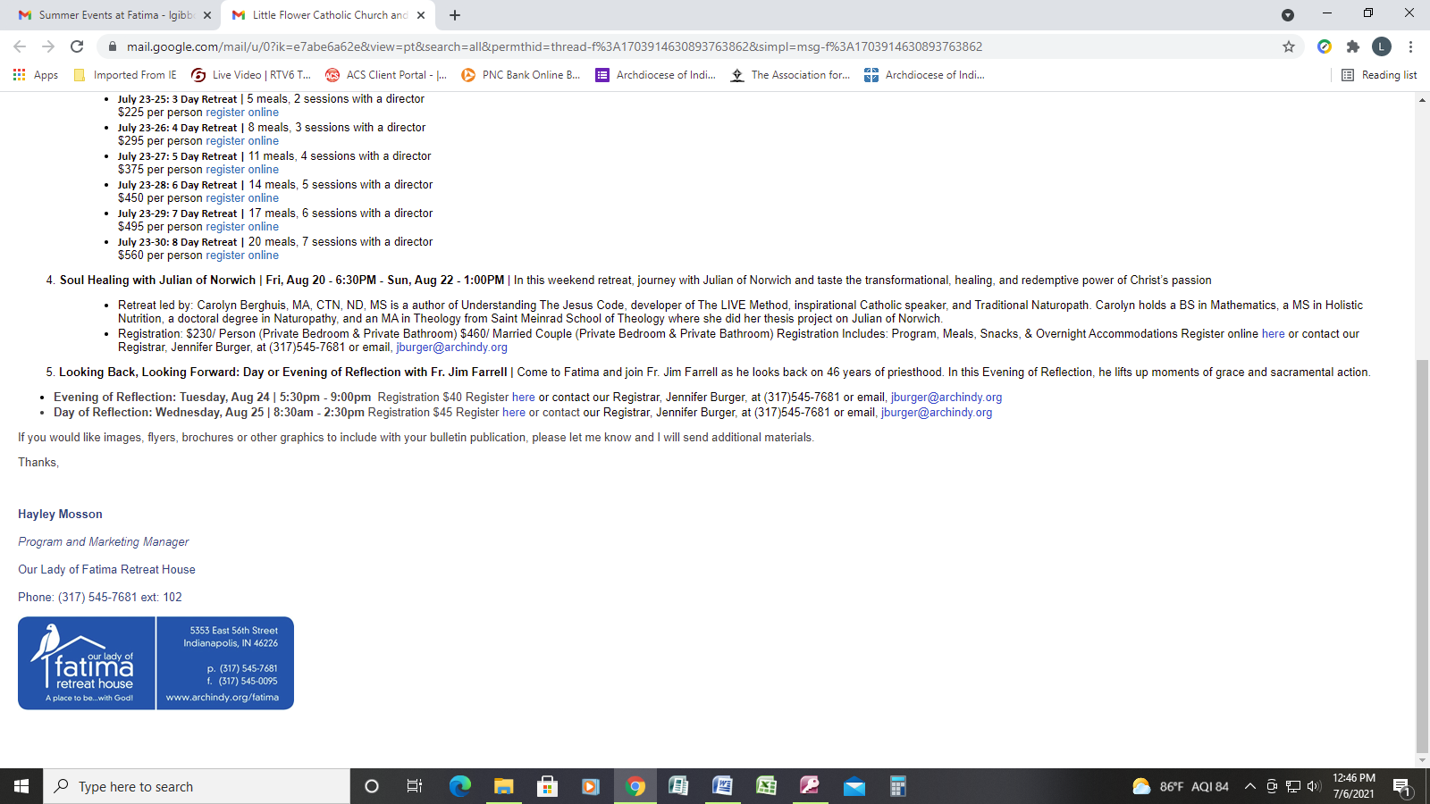

**Summer Programs at**

**Our Lady of Fatima Retreat House**

1. **Day of Silence** | Registration fees: $35.00 includes a room to use for the day, continental breakfast, Mass, lunch, and the use of the common areas and grounds of the retreat house.

* Thursday, August 12
* Tuesday, September 21

1. **You Are Not Alone |**Hope and Healing for Survivors of Suicide Loss Series and Retreat.

* **Sunday, August 15, 2021,** **4 – 6 pm -Spiritual Journey after Suicide Loss** – Fr. Jim Farrell.
* **Saturday, September 25 - Sunday, September 26, 2021 - A Weekend of Hope and Healing for Survivors of Suicide Loss**.

1. **Soul Healing** with Julian of Norwich | **Fri, Aug 20 - 6:30 p.m. - Sun, Aug 22 - 1:00 p.m.** | In this weekend retreat, journey with Julian of Norwich and taste the transformational, healing, and redemptive power of Christ’s passion.

* Retreat led by: Carolyn Berghuis, MA, CTN, ND, MS is an author of *Understanding The Jesus Code*, developer of The LIVE Method, inspirational Catholic speaker, and Traditional Naturopath. Carolyn holds a BS in Mathematics, a MS in Holistic Nutrition, a doctoral degree in Naturopathy, and an MA in Theology from Saint Meinrad School of Theology where she did her thesis project on Julian of Norwich.
* Registration: $230/ Person (Private Bedroom & Private Bathroom) $460/ Married Couple (Private Bedroom & Private Bathroom) Registration Includes: Program, Meals, Snacks, & Overnight Accommodations.

1. **Looking Back, Looking Forward: Day or Evening of Reflection with Fr. Jim Farrell** | Come to Fatima and join Fr. Jim Farrell as he looks back on 46 years of priesthood. In this Evening of Reflection, he lifts up moments of grace and sacramental action.

* Evening of Reflection: Tuesday, Aug 24 | 5:30 p.m. - 9:00 p.m.  Registration $40
* Day of Reflection: Wednesday, Aug 25 | 8:30 a.m. - 2:30 p.m. Registration $45.

You may register online at [http://www.archindy.org/fatima or contact our Registrar, Jennifer Burger, at (317)545-7681, or email](http://www.archindy.org/fatima or%20contact%20our%20Registrar,%20Jennifer%20Burger,%20at%20(317)545-7681,%20or%20email ) [jburger@archindy.org](mailto:jburger@archindy.org).



**MARK YOUR CALENDARS**

**STRUTTIN’ OUR STUFF ANNUAL FUNDRAISER**

St. Vincent de Paul Indianapolis will be hosting its 4th Annual Struttin’ our Stuff on Friday, September 10, 2021 at 6 p.m. at the Northside Events & Social Club, 2100 E. 71st St., Indianapolis. This year we are celebrating SVdP’s 75th year of serving those in need in central and southern Indiana.  The evening will provide dinner, live and silent auctions, and a style show featuring clothing from the Mission 27 Stores. We hope you will join us and consider donating items for our silent and live auctions or support us by becoming a sponsor or a patron. For additional information contact one of the co-chairs: Jenny Matthews 317-289-3324 [jmattbogey@gmail.com](mailto:jmattbogey@gmail.com) or Mary Ann Klein 317-796-6325 [klein.j@sbcglobal.net](mailto:klein.j@sbcglobal.net). It’s a fun event and we hope to see you there!

