Dear Parish Family,

As I am writing this letter, the demolition phase of the parish center construction project is underway. It is both very noisy and very dirty. However, when it is completed, we will be able to welcome physically disabled parishioners and visitors to the parish center.

Thanks to all who attended the Little Flower Novena and who helped make the novena beautiful. Also, although we were not able to hold our annual Parish Appreciation Dinner, our Invite Commission hosted a food give-away on the front steps of the church on Sunday, October 4.

Our parishioner Chris Arvin recently chose to withdraw from the deacon formation program. We want to thank him for choosing to explore a vocation to the diaconate and for everything he has done for the parish since becoming a candidate. For example, he served as RCIA director for one year and, with Andrea, his wife, as the director of our high school confirmation program for two years. He also attended our weekly staff meetings. He will continue to take Communion to the homebound and will continue to lead our partnership with IU Health for at least six months.

He asked me to share a few words with you:

I have withdrawn from the deacon formation program. This past year was very difficult, and after many prayers and much discernment I am now at great peace with my decision. I appreciate all the prayers and concern from my Little Flower family. My health is fine now, and Andrea and I are looking forward to the next chapter of our lives. We wish to continue sharing the good gifts with which God has blessed us.

Very Sincerely,
Chris & Andrea

Thursday, October 15, is the memorial of St. Teresa of Jesus, Virgin and Doctor of the Church. She was a Spanish mystic who, with St. John of the Cross, founded the Discalced Carmelite friars and nuns. Our St. Therese was a member of that order. She was the first woman named a Doctor of the Church. She died in 1582.

Friday is the optional memorial of St. Margaret Mary Alacoque. It was to St. Margaret Alacoque that the Sacred Heart appeared and asked her to promote First Friday devotions. She died in 1690 at the age of 43.

Saturday is the memorial of St. Ignatius of Antioch. He was martyred around the year 107. He was the second successor to St. Peter as bishop of Antioch. He was the first to use the term Catholic Church as a collective designation for Christians.

Have a wonderful week.

Please welcome into our Christian community Grace Diane, daughter of Gabriel and Jennifer (Markins) Lamb, who was baptized on Sunday, October 4, 2020.

For the Week of October 12 - 18, 2020

12 | October | Monday
 | 5:30 p.m. | Joe Bordenkecher by David & Thelma Bray
13 | October | Tuesday
 | 9:30 a.m. | Norbert Arvin by Thomas & Debra West
14 | October | Wednesday
 | 5:30 p.m. | Doris Gilday by Sandy Gilday
15 | October | Thursday
 | 9:30 a.m. | Dottie Spalding by Jeanne O’Gara
16 | October | Friday
 | 5:30 p.m. | Jack Gilmore by Joe & Martha Finneran
17 | October | Saturday – Vigil of the 29th Sunday in Ordinary Time
 | 5:00 p.m. | For the People
18 | October | Sunday – The 29th Sunday in Ordinary Time
 | 9:30 a.m. | Bud Dennemann by the Downs Family
 | 6:00 p.m. | In Thanksgiving for Fr. Bob by Parishioners

Beginning at weekend Masses on Saturday, October 24, and continuing the next week of October 26 in the parish center, you will have an opportunity to help a family in need for Thanksgiving.

Thanksgiving Blessing Bags will be available for pick up. Each bag will have a list of ten items to purchase for a neighborhood family in need for Thanksgiving. Please plan to take a bag if you are able. After completing your shopping, return your filled bag to Masses on the weekend of November 14/15.

“Chillin’ with Fr. Bob”
Thanks to all who have donated so far to our special “Chillin’ with Fr. Bob” campaign to help fund the rectory cooling project. Early estimates for the cost of this project range from $70,000 - $90,000. We will provide a weekly report of the progress of this campaign in The Theresean.

Total donations as of October 4 bulletin $ 42,910.41
Donations received last week $ 350.00
Total donations to date $ 43,260.41

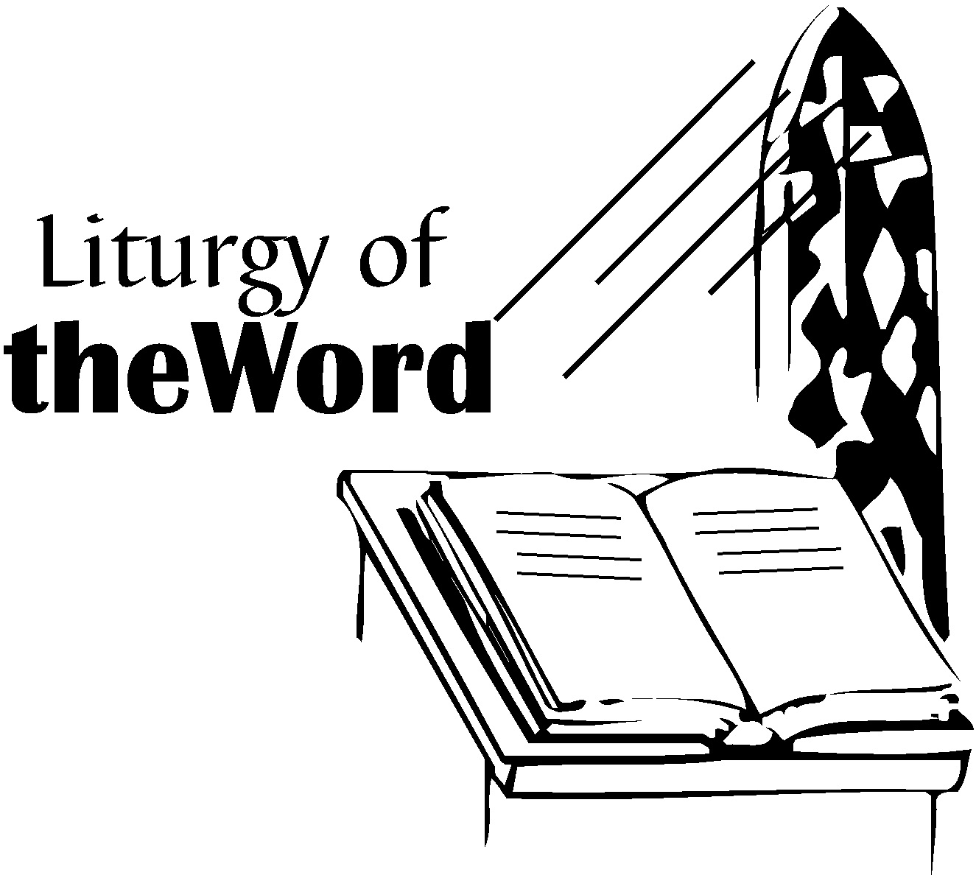
Readings for October 17 and 18
29th Sunday in Ordinary Time

Isaiah 45:1, 4-6
I Thessalonians 1:1-5b
Matthew 22:15-21
To read the readings online, go to:
https://bible.usccb.org/bible/readings/101820.cfm

Next weekend is World Mission Sunday. Please take this opportunity to reach out in faith to more than two-thirds of the world’s people who have yet to hear the Good News of Jesus Christ. Please use your envelope provided in the regular packet and place it in the regular collection next weekend. Please be as generous as possible.

The Center for Disease Control has stated that Halloween Parties with a large number of attendees is a major health risk when it comes to COVID-19. Therefore, in order to keep all children and volunteers healthy and safe, there will NOT be a Halloween Party this year.

STEWARDSHIP CORNER
Your Gifts of Treasure

Weekly Budget Goal | $ 13,000.00
Collection of October 3 and 4 | $ 8,713.00
Electronic Contributions 9/28-10/2 | $ 7,611.84
Fiscal Year 2020-2021 Actual | $ 175,296.61
Fiscal Year 2020-2021 Budget | $ 182,000.00
Fiscal Year 2020-2021 YTD DEFICIT | $ - 6,703.39
Home Improvement Fund
August Contributions | $ 1,990.65
September Contributions | $ 2,121.32
October Contributions (to date) | $ 903.33

On November 5, the Ladies Club will be filling 70 bags of essentials to give to the Cathedral Soup Kitchen to distribute to their clients. This year will be challenging since people are not travelling as much, so we won’t have the travel size toiletries, and Mass attendance is still somewhat low. We have contacted the director of the Soup Kitchen and have a list of needed items:
- Hand sanitizer
- Rain ponchos (Dollar Tree $1 each)
- Bars of soap
- Toothpaste
- Lip balm (Dollar Tree 2 for $1)
We are also providing a pair of socks, a wash cloth, and some hard candy. Baskets for donations will be under the tables at all church doors, or bring to the parish center by November 2. Thank you for your help.

Little Flower received an Archdiocesan Home Mission grant for four AEDs to use in our buildings. Part of the grant money includes training parishioners on how to do CPR and use the AEDs. The training class usually costs $45.00, but we are able to offer it free with money received from the grant. The class will be on Saturday, October 24, from 9:00 a.m. - 12:30 p.m. in the cafeteria. It is highly recommended that any Hospitality Ministers or anyone involved in athletics as coaches or volunteers take advantage of this free class. You never know when you might be called upon to help save someone’s life. Class size is limited, so if you want to attend, please contact Jeannie Zimmerman at jzimmerman@littleflowerparish.org or 317-357-8352 x 103 ASAP. Registration deadline is October 15.

Please keep our ill and homebound parishioners in your thoughts and prayers, especially the following people who have requested prayers for various reasons:

Bill Ajamie, Karen Ajamie, Esther Capps, Roberta Galluzzi, Gene Miller, Joe Swift, Dave Parris, Denice Rose, Martha Haddin, Gary Walters, Haydee Gloria, Charles Aughe, Fr. Paul Koetter, Margie Greene, Molly Hahn, Bill Rathz, Judy Rathz, Scott Rhinehart, Tricia Allstatt, Charlie Goodman, Bobbie Lawless and Catherine McKenna-Sexton.

If you get a chance, please send them a card or a note. It will really brighten their day. This week we especially want to remember:

Mary O’Brien
Little Sisters of the Poor
2345 W. 86th Street, Apt. # 338, Indianapolis, IN 46260

Pray for our active military family/friends:

Brian Ledgerwood, serving on the USS Theodore Roosevelt, son of Diane Anderson.

Victor Franco, serving at Malmstrom Air Force Base in Great Falls, MT.

If you or someone in your family is ill or serving our country and would like their name listed in the bulletin so others can pray for them, please contact Peggy Clegg at 317-357-8352 or pclegg@littleflowerparish.org.

On Sunday, September 27, there was an information meeting regarding confirmation preparation. Confirmation preparation is open to all youth in high school. We are preparing for our first preparation meeting. If you missed the information meeting but are still interested in preparing for the sacrament this year, or if you have any questions, please contact Michele Rosenbaum by email at rosenbaumindy@yahoo.com. Please respond no later than October 15, 2020. Our first Confirmation meeting is scheduled for Sunday, October 18, at 7 p.m. in the Parish Center.

FLU SHOT CLINIC
Community Hospital East is offering FREE flu shots in the Main Lobby.
- Monday, October 12, from 10 a.m. – 3:00 p.m.
- Tuesday, October 13, from 10 a.m. – 3:00 p.m.
- Wednesday, October, 14 from 10 a.m. – 3:00 p.m.
- Thursday, October 15, from 10 a.m. – 3:00 p.m.
- Friday, October 16 from, 10 a.m. – 3:00 p.m.

Little Flower offers Religious Education (CCD) for children in kindergarten to 8th grade who attend public schools. We will meet on most Sundays in Little Flower School from 10:30 a.m. – 11:30 a.m., beginning October 25, 2020 through mid-April 2021. If you have any questions or to register for Religious Ed, please email Lisa at lgibbons@littleflowerparish.org, or call 317-357-8352 ext. 105.

In order to keep all of our senior parishioners safe and healthy, the Adventuresome Group will NOT meet in October. Hopefully we will be able to meet in November or December!

