

Dear Parish Family,

Once again thank you for all the well wishes, birthday cards, and presents for my 70th birthday. More importantly, thank you for your continuing prayers as I undergo my radiation treatments. I have now completed more than half of my treatments. As I have been asking at Mass, please pray not only for my healing but also that I have minimal side effects. I am finding that I am more fatigued each week.

Please note the thank you from Sister Theresia Hhayuma. I also wish to thank you for your generosity to her and her community.

Wednesday, August 21, is the feast of St. Pius X. St. Pius X was Pope from 1903 until 1914. It was Pope Pius X who lowered the age of First Communion from 12 to 7. He also encouraged frequent, if not daily, Communion.

Thursday, August 22, is the feast of the Queenship of Mary. This feast was added to the liturgical calendar by Pope Pius XII in 1954. Originally, it was celebrated on May 31 but was later moved to August 22, the octave day of the Solemnity of the Assumption. It was Pope Pius XII who infallibly defined the dogma of the Assumption on November 1, 1950.

Have a wonderful week.

fr. bob

V11F.tifWe remember our parishioner, **Ruby Thie**, who passed away on August 9 and whose funeral liturgy was celebrated here on August 17. Although she has been a parishioner for many years, Ruby was not able to attend church. We extend our sympathy to *BJ Schmidt* on the death of her father-in-law, **Glen Schmidt,** and her sister, **Mary Cervantes**. Please keep Ruby’s, Glen’s, and Mary’s families and friends in your thoughts and prayers during this difficult time. May God welcome Ruby, Glen, and Mary into his eternal glory.



Little Flower offers Religious Education (CCD) for children in kindergarten to 8th grade who attend public schools. We will meet on most Sundays from 9:30 a.m. – 10:25 a.m. beginning September 22, 2019 through April 2020. If you have any questions, or to register for Religious Ed, please email Lisa at [lgibbons@littleflowerparish.org](mailto:lgibbons@littleflowerparish.org), or call 317-357-8352 ext. 33.



**For the Week of August 19 - 25, 2019**

|  |  |  |
| --- | --- | --- |
| **19** | **August** | **Monday** |
|  | 5:30 p.m. | For the Intentions of Dottie Spalding |
| **20** | **August** | **Tuesday** |
|  | 5:30 p.m. | For the Intentions of Dick & Peg Kramer by Legion of Mary |
| **21** | **August** | **Wednesday** |
|  | 5:30 p.m. | Mary B. Moriarty Adams by Charles & Sheila Lyon |
| **22** | **August** | **Thursday** |
|  | 5:30 p.m. | Souls in Purgatory by John T. Kelly |
| **23** | **August** | **Friday** |
|  | 8:30 a.m. | Frances Dugan |
|  | 5:30 p.m. | Communion Service |
| **24** | **August** | **Saturday – Vigil of The 21st Sunday in Ordinary Time** |
|  | 5:00 p.m. | Jim Hawkins by Kelly Paul Williams |
| **25** | **August** | **Sunday – The Twenty-First Sunday in Ordinary Time** |
|  | 8:30 a.m. | James Gilday |
|  | 10:30 a.m. | Charley Murphy by the Murphy Family |
|  | 6:00 p.m. | For the People |

**V12C.tif**

**August 18 - 25, 2019**

|  |  |  |  |
| --- | --- | --- | --- |
| **DAY** | **ROOM** | **TIME** | **GROUP** |
| **Sunday** | New Parishioner Registration after all Masses. | | |
|  | Church | 8:30 a.m. | Children’s Liturgy |
|  | Duffey Hall | 9:30 a.m. | Coffee and Donuts |
|  | Church | 7:00 p.m. | Youth Choir Practice |
| **Monday** | St. Patrick | 12:30 p.m. | SVDP |
| **Tuesday** | St. Therese | 9:30 a.m. | Legion of Mary |
|  | St. Patrick | 7:00 p.m. | RCIA Team Meeting |
| **Wednesday** | St. Patrick | 6:00 p.m. | Finance Council |
|  | Duffey Hall | 7:00 p.m. | Men’s Club |
| **Thursday** | St. Therese | 8:00 p.m. | AA |
| **Friday** |  | | |
| **Saturday** |  | | |
| **Sunday** | Church | 8:30 a.m. | Children’s Liturgy |
|  | Parish Grounds | 11:30 a.m. | Parish Picnic |
|  | Church | 5:00 p.m. | Youth Choir Practice  Sing at 6 p.m. Mass |

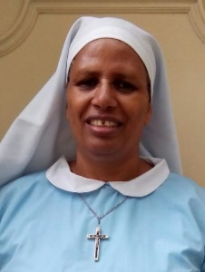Thank you for your generosity to the Daughters of Mary of Tabora, Tanzania. Thank you for your warm welcome and support for the Community of the Daughters of Mary and the work they are doing to help the poor in Tanzania. Your generous support of the Community will continue to make a difference in the lives of those in need throughout the entire year. Thank you to all for your generosity. Be assured also of our prayers, and may God bless you always. Sister Theresia Martin Hhayuma.



|  |  |
| --- | --- |
| **STEWARDSHIP CORNER**  **Your Gifts of Treasure** | |
| **Weekly Budget Goal** | **$ 13,550.00** |
| **Collection of August 10 and 11** | **$ 6,318.39** |
| **Electronic Contributions 8/5 – 8/9** | **$ 3,389.00** |
| **Fiscal Year 2019-2020 Actual** | **$ 88,951.15** |
| **Fiscal Year 2019-2020 Budget** | **$ 94,850.00** |
| **Fiscal Year 2019-2020 YTD DEFICIT** | **$ - 5,898.85** |
| **Home Improvement Fund** | |
| **June Contributions** | **$ 2,245.83** |
| **July Contributions** | **$ 2,539.83** |
| **August Contributions (to date)** | **$ 1,324.00** |

***Please keep our ill and homebound parishioners in your thoughts and prayers, especially the following people who have requested prayers for various reasons***:

Bill Ajamie, Karen Ajamie, Esther Capps, Rita Foley, Ed Galluzzi, Roberta Galluzzi, Richard “Dick” Mayer, Gene Miller, Judy Moss, Joe Swift, Dave Parris, Denice Rose, Martha Haddin, Gary Walters, Haydee Gloria, Vicki Spalding, Dottie Spalding, Dane Kramer.

If you get a chance, please send them a card or a note. It will really brighten their day. This week we especially want to remember:

**Agnes Evrard**

**1223 N Edmondson, Indianapolis, IN 46219**

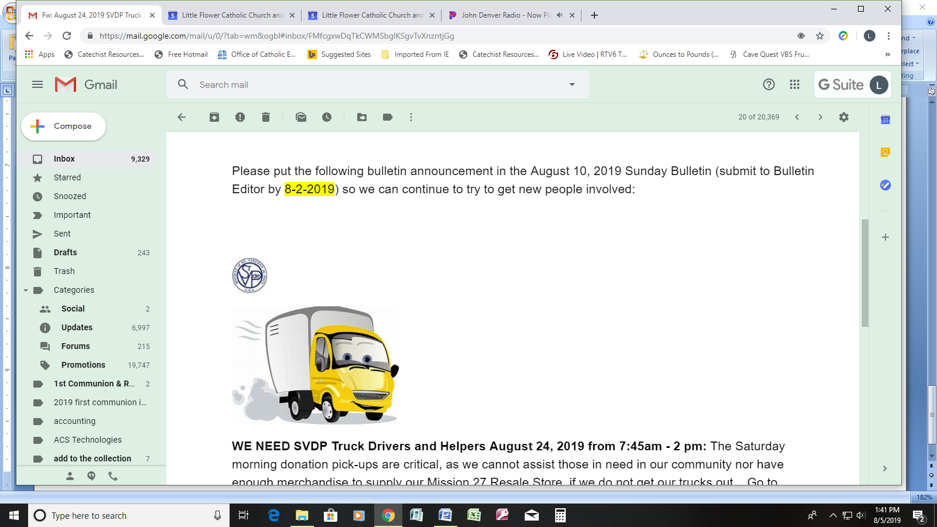**If you or someone in your family is ill or serving our country and would like their name listed in the bulletin so others can pray for them, please contact Peggy Clegg at 317-357-8352 or** [**pclegg@littleflowerparish.org**](mailto:pclegg@littleflowerparish.org)**.**



**(grades 8 thru 12)**

**YOUTH CHOIR** will practice on Sunday, August 18, from 7 p.m. until 8:15 p.m. in Church. New members are needed. This is also the time of year when we welcome those entering eighth grade. Parents, encourage your kids in grades 8 through 12, and consider making the sacrifice to help them participate. They practice one Sunday evening per month and sing at the 6 p.m. Sunday evening Mass on the 1st and 4th Sunday of each month, arriving at 5 p.m. to practice before Mass. This group makes a huge contribution to our liturgy!



The Spalding family would like to thank Little Flower parish for the prayers, special intentions, and Masses said for our family. It has provided great comfort during a difficult time.



**ANNUAL GOLF OUTING**

The 20th Annual Father Robert Borchertmeyer Golf Outing will be on Friday, September 6, at 10:30 a.m. at Pleasant Run Golf Course and is only $75 this year. For more information, there are fliers at all doors.  Please contact Jeff Lyons at [317-294-9242](tel:(317)%20294-9242) or [jeffly200@gmail.com](mailto:jeffly200@gmail.com) if you are interested in playing or have questions.

It’s not too soon to think about joining the adult choir this fall. The adult choir sings at the 8:30 A.M. Mass on most Sundays from September through May. Practices are held on most Tuesday evenings from 7:00 P.M. until 8:30 P.M. **We could use some new voices in all voice sections, with a significant need in the men’s sections**. *No previous experience is necessary!!* Please start to give some serious thought to see if God is calling you to serve in this important ministry. Practices begin on Tuesday, September 3. If you have questions, call Tom at 357-8352, ext 27 or e-mail [tcostello@littleflowerparish.org](mailto:tcostello@littleflowerparish.org).

V9E.tifThe next **Baptism Preparation Class** is **Monday, August 26**, at **7:00 p.m.** in the Parish Center. This class is required for parents who are requesting baptism for their child and have not previously attended a preparation class. Please call the parish center at 317-357-8352 to let us know you plan to attend. Plan ahead, as the next class will not take place until November.

**WE NEED SVDP Truck Drivers and Helpers August 24, 2019 from 7:45 a.m. - 2 p.m.**The Saturday morning donation pick-ups are critical. We cannot assist those in need in our community or have enough merchandise to supply our Mission 27 Resale Store if we do not get our trucks out. Go to <http://www.signupgenius.com/go/508084da5a628a0fa7-saturday>  to establish a username/password and to sign-up; or call Larry at [317-657-7093](tel:317-657-7093) if you need help signing up or have questions.   Please arrive at the SVDP Distribution Center at 1201 E. Maryland Street between 7:30 a.m. - 7:45 a.m.

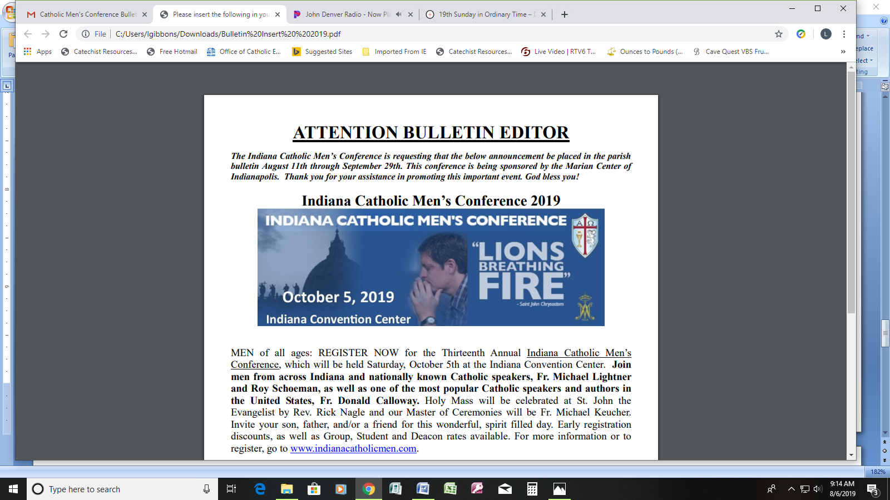 MEN of all ages: REGISTER NOW for the Thirteenth Annual Indiana Catholic Men’s Conference, which will be held Saturday, October 5, at the Indiana Convention Center. Join men from across Indiana and nationally known Catholic speakers, Fr. Michael Lightner and Roy Schoeman, as well as one of the most popular Catholic speakers and authors in the United States, Fr. Donald Calloway. Holy Mass will be celebrated at St. John the Evangelist by Rev. Rick Nagle, and our Master of Ceremonies will be Fr. Michael Keucher. Invite your son, father, and/or a friend for this wonderful, spirit-filled day. Early registration discounts, as well as Group, Student and Deacon rates available. For more information or to register, go to www.indianacatholicmen.com.

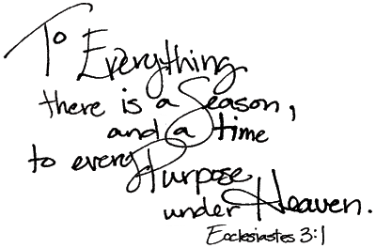

**2019 LF Bible Study attendee: “Being a part of a small group and learning God’s Word is helping me to understand my faith in a new way. Jeff Cavins’ pace was just right and meeting new people was the icing on the cake. Can’t wait for the next session.”**

**The INVITE Commission presents:**

**WISDOM: God’s Vision for Life (Ascenion Press, Jeff Cavins)**

**This eight-week study will take us through the books of Proverbs, Wisdom, Sirach, and Ecclesiastes as we learn how Bible wisdom relates to daily life.**

**DATES, TIMES, LOCATION**

**Every Monday evening from 7:00 p.m. - 8:30 p.m.**

**September 9 - October 28,**

**Duffey Hall**

**COST/REGISTRATION: $20.00**

**Contact: Cac Diehr, 317-501-0060,** [**cac.diefr@gmail.com**](mailto:cac.diefr@gmail.com) **for more information or to register.**

**Babysitting Available**

**MCj04401490000[1]**

MC900233051[1]MCj03361540000[1]

**Little Flower Parish Picnic**

**Sunday, August 25**

**Following 10:30 a.m. Mass**

**On the Parish Grounds**

**All are welcome!**

**Please join us for**

**an exciting day!**

**Lunch after**

**10:30 a.m. Mass**

**Games & Bingo**

**after lunch.**

**Water Slide:** There will be a water slide for children ages 3-3rd grade weighing less than 90 pounds. Children younger than 3 may slide with a parent present. **Swimsuits must be worn.** Don’t forget to bring a towel!

**Please meet outside the Parish**

**Center at 9:30 a.m. if you are able to help with setting up tables and chairs. Help will also be needed after the picnic is over to return the tables and chairs to the cafeteria!**

**Don’t miss out on all the fun!**

***Fried Chicken, Drinks & All***

***Paper Products Provided***

**Please bring a dish to share**

**that will feed at least 10-12 people.**

**In the past we have run out of food.**

**We don’t want anyone to go hungry!**

**If your Last Name Begins With:**

**A**—**F** Cold Dish – pasta salad, macaroni salad, veggies, etc.

**G—M** Hot Dish – mac and cheese, baked beans, au gratin potatoes, etc.

**N—S** Cut fruit/cut veggies, relish tray, fruit

tray, cut watermelon.

**T—Z** Desserts – cake, brownies, cupcakes, cookies, etc.

Hosted by the Parish Life Commission

Hosted by the Parish Life Commission