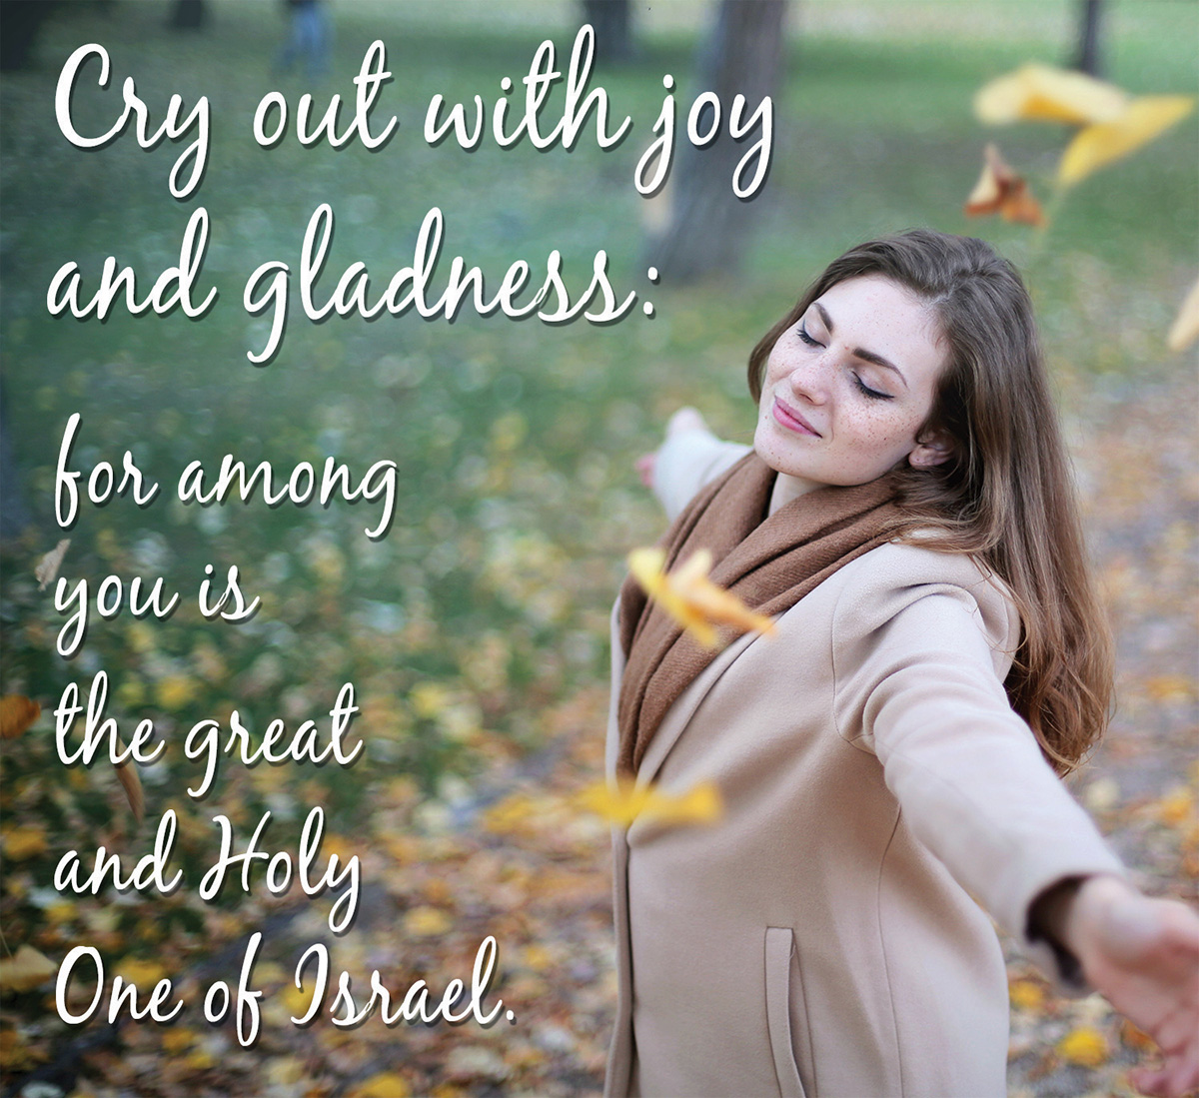
Dear Parish Family,

The Third Sunday of Advent is called Gaudete Sunday. The Latin word gaudete means rejoice. At the midpoint of Advent, we are called to rejoice because the coming of the Lord is near. As a sign of joy, the vestment color today is rose. Also, the third candle of the advent wreath is rose. Two verses from St. Paul’s Letter to the Philippians capture the spirit of the day: “Rejoice in the Lord always; again I say, rejoice.... The Lord is near” [4:4-5].

Thanks to all who brought gifts for the Christmas giving tree. Special thanks to the St. Vincent de Paul Society for all their hard work coordinating the Christmas giving tree project.

Likewise, thanks to the Parish Life Commission and all those who assisted them in planning and hosting our wonderful Christmas Party. Thanks to all those who helped with set up, cooking, and tear down. Thanks to Santa and Mrs. Claus who met with the children. Finally, thanks to all who attended.

Also, thanks to Dr. Martha Thie who presented the Joseph and Veronica Thie Memorial Service Award to ten Little Flower School students last Sunday at the 10:30 a.m. Mass. We are grateful to the Thie family for the award, to Martha Thie for presenting the award, and to members of the Thie family who attended.

Thanks to the priests who helped with our Advent Penance Service. The following received the Sacrament of Reconciliation for the first time last Monday evening:

Wesley Busby | Broderick Glawatz | Emerson St. Amour
Dorothy Cheever | Anthony Hollada | Harper St. Amour
Melody Chicas | Landon Laurenzana | Paisley Torzewski
Isabel Crawford | Merryn Leffler | Katie Vokes
Lyra Eskew | Cecilia Pertile | Joscelyn Winters
Jeremiah Gascon | Zoe Smith

We can take comfort that sunset is already later than it was earlier in December. The earliest sunset occurs at 5:20 p.m. December 6-9. Sunset today is 5:22. Unfortunately, the latest sunrise will not occur until January 4-5 when it will rise at 8:07 a.m.

Finally, as the calendar year draws to close, we are running a Sunday collection deficit. If anyone is planning a donation before the end of the year, it should be received in our office by December 31, 2018.

Have a wonderful week.

fr. Bob

Please remember to bring your unwrapped gifts for Baby Jesus to support our Gabriel Project babies to all Christmas Eve and Christmas Day Masses. We are greatly in need of body lotions, body wash, bath towels and wash cloths, socks, wipes, bottles, bottle brushes, and diapers especially size 3, 4, and 5. Thank you for your support!



For the Week of December 17 - 23, 2018

17 | December | Monday
 | 5:30 p.m. | Martha Commons
18 | December | Tuesday
 | 5:30 p.m. | Communion Service
19 | December | Wednesday
 | 5:30 p.m. | For the Intentions of Bill Ross by Paul Commiskey
20 | December | Thursday
 | 1:30 p.m. | at Green Briar – Souls in Purgatory by John T. Kelly
 | 5:30 p.m. | Communion Service
21 | December | Friday
 | 8:30 a.m. | Ruth Axsom by Marty Kiemer
 | 5:30 p.m. | Communion Service
22 | December | Saturday – Vigil of the Fourth Sunday of Advent
 | 5:00 p.m. | Tom O’Gara by Jeanne O’Gara
23 | December | Sunday – Fourth Sunday of Advent
 | 8:30 a.m. | For the People
 | 10:30 a.m. | Mary Moriarty Adams by the Downs Family
 | 6:00 p.m. | Norm McCarty by Benny Banayote Jr.



December 16 -23, 2018

DAY | ROOM | TIME | GROUP
Sunday | New Parishioner Registration after all Masses
 | Church | 8:30 a.m. | Children’s Liturgy
 | School | 9:30 a.m. | Religious Ed
 | School | 9:30 a.m. | RCIA for Children
 | Duffey Hall | 9:30 a.m. | Coffee and Donuts
 | Church | 7:00 p.m. | Youth Choir Practice
Monday | St. Patrick | 1:30 p.m. | SVDP
 | St. Therese | 6:30 p.m. | SoulCore
Tuesday | St. Therese | 9:30 a.m. | Legion of Mary
 | Duffey Hall | 6:30 p.m. | LF Neighborhood Association Chili Challenge
 | St. Therese & St. Patrick | 7:00 p.m. | RCIA
 | Church | 7:00 p.m. | Christmas Choir
Wednesday | Parish Office Closes at Noon
Thursday | St. Therese | 8:00 p.m. | AA
Friday
Saturday
Sunday | Church | 8:30 a.m. | Children’s Liturgy
 | Church | 5:00 p.m. | Youth Choir Practice  Sing at 6 p.m. Mass


We extend our condolences to Dick and Peg Kramer and their family on the death of Peg’s brother, Rick Fane, who passed away on December 7. Please keep all of Rick’s family and friends in your thoughts and prayers. May God welcome Rick into his eternal glory!

CHRISTMAS MASS SCHEDULE

Christmas Eve, Monday, December 24

4:00 P.M., 5:30 P.M.,10:00 P.M.

Full Christmas Choir at
10:00 P.M. Mass (beginning at 9:30 P.M.)

Christmas Day, Tuesday, December 25 - 9:00 A.M.

Bulletin Submission Deadlines for the Holidays
This is the busiest time of the year for all of us, and with it comes deadlines. To ensure we have the bulletin available for the weekends of December 29/30, and January 5/6 we ask that any bulletin requests be submitted as follows:
- For December 29/30 bulletin - all submissions must be in by Wednesday, December 19, at 9:00 a.m.
- For January 5/6 bulletin - all submissions must be in by Wednesday, December 26, at 9:00 a.m.
These deadlines are firm due to office closures for the Holidays and delivery of bulletins. Please email submissions to Lisa Gibbons at lgibbons@littleflowerparish.org.

Please remember our parishioners who are ill, homebound, or in a nursing home in your thoughts and prayers. If you get a chance, please send them a card or a note! This week we especially want to remember: Roberta Galluzzi
9191 Garrison Dr Apt 104B, Indianapolis, IN 46240

STEWARDSHIP CORNER

Many thanks to the Parish Life Commission for their hard work on the parish Christmas party. A great time was had by all!

Weekly Budget Goal | $ 13,550.00
Collection of December 8 and 9 | $ 14,868.64
Electronic Contributions 12/3 – 12/7 | $ 6,751.50
Fiscal Year 2018-2019 YTD Actual | $ 315,900.68
Fiscal Year 2018-2019 YTD Budget | $ 325,200.00
Fiscal Year 2018-2019 YTD DEFICIT | $ - 9,299.32
Home Improvement Fund
October Contributions | $ 2,515.33
November Contributions | $ 2,205.83
December Contributions (to date) | $ 1,290.50
United Catholic Appeal
(gifts processed as of 11/29)
Parish Goal $ 50,658.00
# of gifts received or pledges 127
Amount of gifts received or pledged $ 26,053.00

PLEASE NOTE: If you would like a donation to be credited in 2018, it must be received in the collection no later than the weekend of December 29/30 or the parish office by December 31. Also, any donations received in the envelopes marked for the Solemnity of Mary, Mother of God (New Year’s Day) will be credited in 2019.


Rite of Christian Initiation of Adults
Last week we heard John the Baptist proclaim a baptism of repentance for the forgiveness of sins…”The voice of one crying out in the wilderness: ‘Prepare the way of the Lord, make his path straight.” This week, John told the crowd, “Whoever has two coats must share with anyone who has none; and whoever has food must do likewise.”

This week’s topic is, “Eschatology: The Last Things” presented by Mike Haigerty. You are invited to join us on Tuesday, December 18, at 7 p.m. in the Little Flower Parish Center, we finish at 8:30 p.m. Light refreshments and snacks are provided. Have questions? Email carvin@littleflowerparish.org or call the Parish Center 317-357-8352. All are welcome!


Wanted: More Members for the
Church Cleaning Ministry!
Depending on the interest to this ad, you would clean every 7 – 8 weeks. This would be a year commitment. It takes 2 – 3 hours per 7 – 8 weeks. This ministry is a great fit for a large family, or a group of four that would enjoy cleaning together. Please email Michele Rosenbaum at rosenbaumindy@yahoo.com or call 317-443-7342.


Spreading the Holiday Scrip
Shopping Cheer!
The last day to order for your Christmas needs is:
Tuesday, December 18
You may drop off order forms at the Parish Office, through School, or the collection basket. We also have an assortment of gift-cards on hand to purchase. If you have any questions, please call Lisa at the parish office, 357-8352 ext. 33.


Little Flower Ladies Club
Christmas Event

Thursday, December 20 - Meet in the school parking lot at 6 p.m. for Christmas Caroling at several east side nursing facilities. Only requirement is Christmas spirit, singing voice is optional.


The Little Flower Invite Commission is once again bringing Christ Life to our parish! The first series “Discovering Christ" is an opportunity to strengthen your personal relationship with Jesus. Anyone over 18 is welcome to attend. Please consider joining us for this worthwhile program. Space is limited, so please register early. Each session will begin with a free dinner, followed by a video teaching and a discussion with fellow participants. All sessions will be held at Little Flower Parish in the school cafeteria from 6:30 - 8:30 p.m. (Please use door 6 to enter the cafeteria.)The dates are: January 14, 21, 28, February 4, 11, 18, and 25. There is a retreat is on Saturday, February 16 from 9:00 a.m. - 2:00 p.m. You may register online at https://eventbrite.com/e/discovering-christ-tickets-53107136876. You may also register by contacting Peggy Clegg at pclegg@littleflowerparish.org or 317-357-8352 x32.


(grades 8 thru 12)

YOUTH CHOIR – new members are always welcome!
Sunday, December 16 Practice - 7 p.m. to 8 p.m. in church.
Sunday, December 23 Sing at 6:00 p.m. Mass-meet at 5:00 p.m. in church.
Monday, December 24 Sing at 4:00 p.m. Mass-meet at 3:15 p.m. in church.
Sunday, January 6: Sing at 6:00 p.m. Mass-meet at 5:00 p.m. in church.

