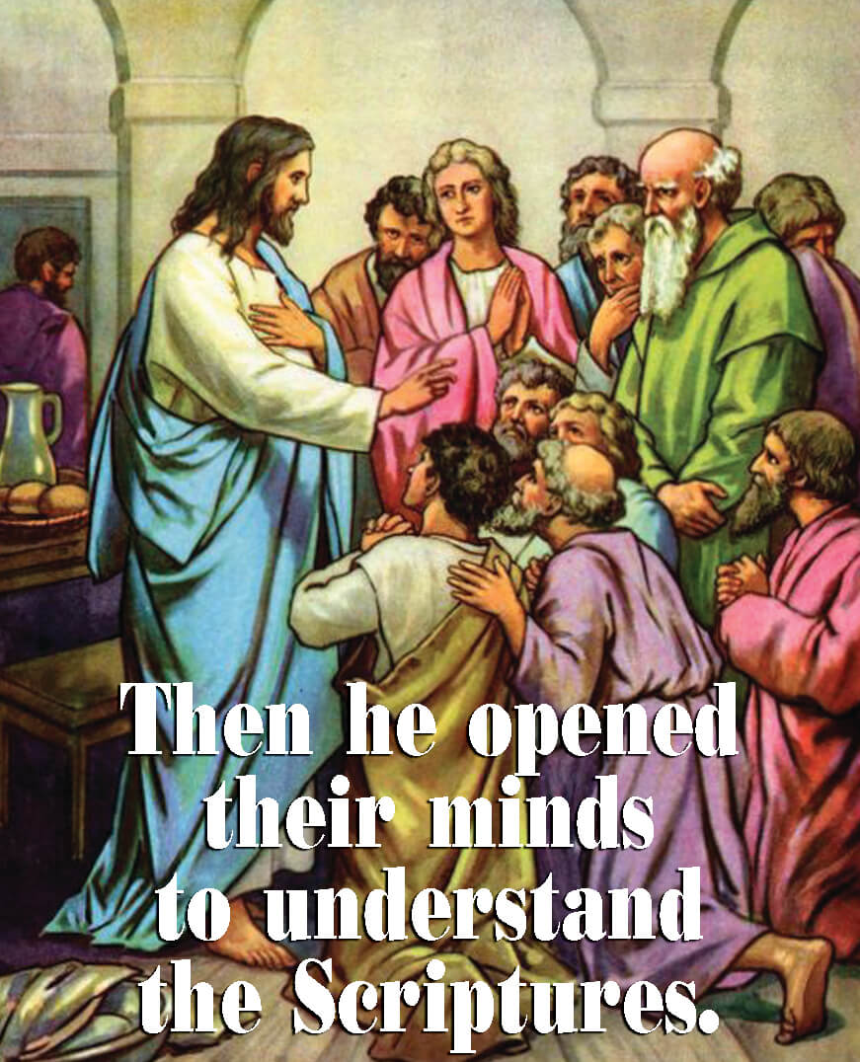
Dear Parish Family,

A very special thanks to David Leszcynski who every year designs and decorates our Paschal Candle. Every year he creates a new design. If you have not looked at the design of this year’s Paschal Candle, I invite you to do so.

This Tuesday, April 17, is the 79th anniversary of the death of Fr. Charles Duffey, the founding pastor of Little Flower. Founding pastors play a profound role in shaping the personality and culture of a parish.

Tuesday I will celebrate Mass for the Sisters at Oldenburg. Two or three times a year the Sisters ask me to celebrate Mass for them. I always enjoy the opportunity to visit with the Sisters, especially Sr. Martine Mayborg, who was my 1st grade teacher here at Little Flower.

Have a wonderful week.

fr. bob


Little Flower School News

On My Way PreK voucher applications are now available.
For more information go to http://in.gov/fssa/carefinder/4932.htm

Little Flower does accept On My Way PreK vouchers. Families receiving PreK vouchers may be eligible for a Choice voucher for Kindergarten. Call the school office for more details, 317-353-2282.

Registration for next year is ahead of where we were last year when we eventually had to close several classes. Please do not delay in registering as registration is now open to new families and seats are no longer guaranteed. All fees must be up-to-date before you may register.


The next Baptism Preparation Class is Monday, April 23, at 7:00 p.m. in the Parish Center. This class is required for parents who are requesting baptism for their child and have not previously attended a preparation class. Please call the parish center at 317-357-8352 to let us know you plan to attend. Plan ahead as the next class will not take place until June.

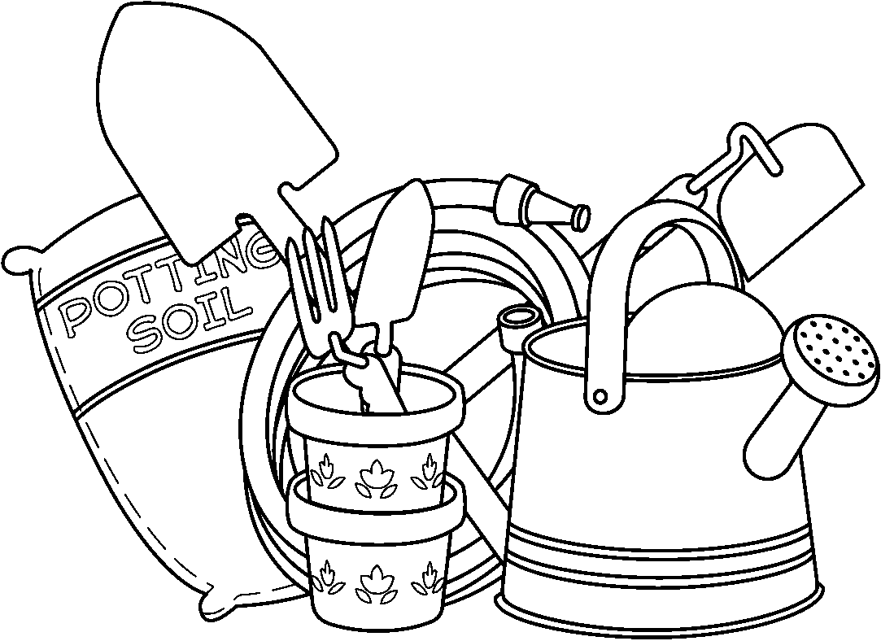
Do you want to volunteer, but your schedule doesn’t allow you to attend regular meetings or adhere to a group’s calendar? Do you like being outside and don’t mind getting your hands a little dirty? We may have just the opportunity for you! The Green Thumb ministry is looking for a few good folks to take over general maintenance of some of the gardens around our campus. You don’t need to be an experienced gardener to help make our grounds beautiful. If you think you might be interested in this rewarding effort, please contact Louise Earlywine at 765-438-3510 or lmfaust1@juno.com for more information.

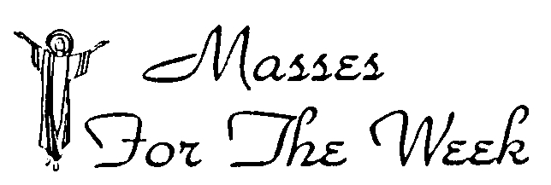
For the Week of April 16 - 22, 2018

16 | April | Monday
 | 5:30 p.m. | Michael Ley by Carol Freeland
17 | April | Tuesday
 | 5:30 p.m. | Communion Service
18 | April | Wednesday
 | 5:30 p.m. | Bob Dangler by Mary and Pat Hull
19 | April | Thursday
 | 1:30 p.m. | Green Briar – Fr. Timothy Sweeney, O.S.B.
 | 5:30 p.m. | Communion Service
20 | April | Friday
 | 8:30 a.m. | Vivan Schmitt by Ladies Club
21 | April | Saturday-Vigil of the 4th Sunday of Easter
 | 5:00 p.m. | Jim Hawkins by Bob and Mary Sitzman
22 | April | Sunday – The Fourth Sunday of Easter
 | 8:30 a.m. | Teresa Eckrich by Judy Gray
 | 10:30 a.m. | Jim Dunn by Bev and Pat Blankenship
 | 6:00 p.m. | For the Parish

April 15 - 22, 2018

DAY | ROOM | TIME | GROUP
Sunday | Blood Pressure Check after all Masses
 | Church | 8:30 a.m. | Children’s Liturgy
 | School | 9:30 a.m. | Religious Ed
 | Duffey Hall | 9:30 a.m. | Coffee and Donuts
 | Church | 7:00 p.m. | Youth Choir Practice
Monday | Scout Room | 6:00 p.m. | Cub Scouts
 | Holy Family | 6:30 p.m. | SoulCore
 | Duffey Hall | 7:00 p.m. | Following Christ
Tuesday | St. Therese | 9:30 a.m. | Legion of Mary
 | St. Therese | 7:00 p.m. | RCIA
 | Church | 7:00 p.m. | Choir
 | Duffey Hall | 7:00 p.m. | LF Neighborhood Association
 | Gym | 7:30 p.m. | LF Athletic Commission
Wednesday | St. Patrick | 6:00 p.m. | Finance Council
 | St. Therese | 7:00 p.m. | Festival Food Chairpersons
Thursday | St. Patrick | 7:00 p.m. | 8th Grade Parent Meeting
 | St. Therese | 8:00 p.m. | AA
Friday
Saturday | John 23rd | 9:00 a.m. | Gabriel Project
 | New Parishioner Registration after all Masses
Sunday | Church | 8:30 a.m. | Children’s Liturgy
 |  | TBA | Confirmation Retreat
 | School | 9:30 a.m. | Religious Ed
 | Duffey Hall | 9:30 a.m. | Coffee and Donuts
 | Duffey Hall/Church | 11:30 a.m. | First Communion Practice and Lunch
 | Church | 5:00 p.m. | Youth Choir Practice/  Sing at 6 p.m. Mass


Confirmation candidates will gather for a retreat day on April 22. Candidates will be sent meeting time details by email.

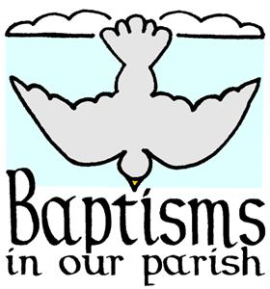
Congratulations to the following families whose children were baptized on Sunday, April 8, 2018:

- Eileen Clare, daughter of Joshua and Kelly (Schlattman) Orndorff
- Kalleah Eileen and Kashtian James, children of Jeremy and Katie (Wieczorek) Pettet
- Azaylia Jade, daughter of Amber Slye
- Rain James, Sky Ryan, Violet Madeline, Hazel Cherish, children of Ryan and Liz Davis

New Minister Schedule
Eucharistic Ministers & Altar Servers, the new schedule for the months of June, July, and August will be coming out soon. Deadline date is May 8.
- Eucharistic Ministers, please send any changes to Ron Sharp via email duvkote@aol.com or 317-356-3488.
- Altar Servers, please send changes to Lisa Gibbons at lgibbons@littleflowerparish.org or 317-357-8352 ext. 33.


The next issue of the parish newsletter, “The Little Flower Garden,” will be distributed in mid-May. Any news or photos you have to share about Little Flower parishioners, ministries, or activities should be sent to the parish office (or dropped in the offering basket) by Wednesday, April 18. You may also e-mail items to lfparishnews@yahoo.com.

FESTIVAL NEWS
SUMMERFEST 2018 – June 1, 2, and 3
Permit #146498

Our next leadership team meeting is
Wednesday, April 25, at 7 p.m. in the parish center.

SPONSORSHIPS ARE CRITICAL TO THE SUCCESS OF THE FESTIVAL, AND WE NEED YOUR HELP! Businesses will benefit by special signage and announcements throughout the festival acknowledging their sponsorship. Business sponsorships start at $250.00, and higher levels are also available with more benefits. If you know of individuals or businesses who might be interested in this opportunity, ask them to call Angie at the parish center (317-357-8352) for more information. If you prefer, you can leave their name and address for Angie, and she will mail information to them. Our best chance of getting new sponsors will be you asking them to help!

Used Book Sale –Please bring your donations of used books to the Parish Center during regular office hours (9 a.m. to 3 p.m. M-F).

The Silent Auction team needs your help. Call Mary Martha Costello at 317-544-0473 or Rosemary Armour at 317-372-5513 if you or your employer can donate new goods or services valued in excess of $25.00.

ATTENTION COLTS OR PACERS SEASON TICKET HOLDERS
Would you be willing to donate a pair (or more) of your tickets for just one game next year? The Silent Auction could use your donation. Please call Mary Martha Costello or Rosemary Armour at the numbers listed above.

Request for Proposals
Are you or someone you know involved in the apparel business? The Little Flower PTO is exploring vendor options for the 2018-2019 school year. The PTO works with the vendor to hold apparel sales 2-3 times each year. Items include required uniform polos and other shirts, hats, etc. These items need to be screen-printed or embroidered with the Little Flower logo. Interested vendors should submit a proposal by email (limit 2 pages) to littleflowerschoolpto@gmail.com by April 30. Please include a list of products available, costs, turnaround times, online sale capabilities, and contact information.


(grades 8 thru 12)

Sunday, April 15: Youth Choir will practice from 7 p.m. until
8:15 p.m. in Church.

Sunday, April 22: Youth Choir will sing at 6 p.m. Mass. Meet in Church at 5 p.m.

New members are always welcome.


Ever want to trade places with the dealer at your favorite casino? Or just interested in how it all works? The Monte Carlo tent at the Little Flower Festival is in need of workers on Friday, June 1, and Saturday, June 2! No background in Blackjack is required, just a desire to help the parish! We need help everywhere in the tent. For example, we will need shufflers to keep the game going. Let us know if you need a refresher course. Please contact Bill Schlosser at 317-408-9869 or email at wpsbuffett@yahoo.com. Must be 21 years old or above.

Please remember our parishioners who are ill, homebound, or in a nursing home in your thoughts and prayers. If you get a chance please send them a card or a note! This week we especially want to remember Jeanne O’Gara
9038 Chestnut Court, Indianapolis, IN 46260

STEWARDSHIP OF TIME, TALENT AND TREASURE
YOUR GIFTS TO GOD AND PARISH

Weekly Budget Goal | $ 13,500.00
Collection of April 7 and April 8 | $ 11,291.81
Electronic Contributions 4/2 – 4/6 | $ 6,931.50
Fiscal Year 2017-2018 YTD Actual | $ 567,778.70
Fiscal Year 2017-2018 YTD Budget | $ 553,500.00
Fiscal Year 2017-2018 YTD | $ 14,278.70
Home Improvement Fund
February Contributions  March Contributions | $ 1,799.83  $ 2,105.33
April Contributions (to date) | $ 1,347.00
United Catholic Appeal
(gifts processed as of 4/5)

The Archdiocesan United Catholic Appeal, Christ Our Hope, has been going on for about 22 weeks, and as you can see we are still almost $9,000 short of our goal, and only 18% of parish households have participated. The Archdiocese will soon begin follow up with those who have not responded. Will you please consider helping us reach our goal? You should have received your intention card in the mail, but there are extras available at the church doors. If you have not yet turned your card in, please do so as soon as possible. You may place them in the regular collection or mail them to the Archdiocese in the envelope provided. Please be as generous as possible to help our parish meet our goal. The United Catholic Appeal funds many shared ministries from which all parishes benefit.

Parish Goal $ 45,060.00
# of gifts received or pledges 160
Amount of gifts received or pledged $ 35,948.00

If you have not returned your annual stewardship intention card, please return it as soon as possible. Extra cards are available at the church doors if needed.

PLEASE CONSIDER REMEMBERING
LITTLE FLOWER PARISH AND SCHOOL
IN YOUR ESTATE PLANNING.

Donated ByIn Honor Of

The Belles FamilySarah Jane Belles
Jim and Veronica Doig
Rose and Gerald Belles

Patricia BowronOlive F. Bowron

Butch and Donna BrownChristopher Cardis
Mary Miller
Maude Brown

Nancy BrownGordon and Frances Harris
Frances Brown

Tom and Julie BullockSusan Dugan
FamilyJerry Bullock

Robert and Gerry BurginDeceased Loved Ones of the Burgin Family

Jim and Debbie BurksEverett and Grace SpurlinSuzan Burks

Paul and Sandy CleggJim Hawkins
Brian Hawkins
John and Rosie Clegg
Zac Clegg

Judy CorpuzHelen Clager

Ellen CorridenEllen (Leonard) Falvey
Maureen (Falvey)
Larner-Reeser

Tom and Mary MarthaJim and Evelyn Babcock
CostelloTom and Eileen Costello
Tom Burke
Teresa Eckrich

Robert Dew Sandra Dew

Regina DewPat Hernandez

Kadee Dew Chris, Karlene, Emiel Fabyan

Donated ByIn Honor Of

Douglas DonahueMichael and Clara Donahue

Maureen DuncanEdward, Marcia, and Alan Duncan

Carol FreelandMichael and Carolyn Ley Daniel and Jim Freeland

Dorothy FulnerPaul Fulner
Tony Fulner
Loretta McCafferty
Donna Bizzle

C. M. GillThe Farrell and Gill Families

Cathy and Bill GortonDeannie Gorton

Pauline and Charlie GrafWalter & Anna Bordenkecher
Charles & Lillian Graf
Anita, Charles, and Ruth
Bordenkecher
Phyllis and Bob Metzler
Norman Bordenkecher
Bill and Mike Bordenkecher Leo Kennedy, and Ron Hines

Portia GravesNaomi Hodge Asher Grant
Ardis Danner Graves
Irene Wade
Alice Davis
Mary Francis Dugan

Steve and FernandaIda and Romeo Girolami
GrohovskyMary and Joseph Grohovsky

Martha HaddinGeorge Haddin

Jean JettJerry Jett

William and Joann Frank and Stella Mayer
Johnson

Mark and Cathy KippertPhillips, Henriksen, Flowers, and Few Families
Kippert, Baumann, and
Robinson Families

EASTER FLOWER
MEMORIALS
The Parish gratefully acknowledges all those who purchased blooming plants in honor of loved ones for our use during the entire Easter season

